

Schools Safeguarding Policy Framework for Children and Young People

Safeguarding is everyone’s responsibility

“Schools, colleges and other educational providers have a pivotal role to play in safeguarding children and promoting their welfare.”
Working Together to Safeguard Children 2018

Safeguarding Children in Education
Safeguarding and Quality Assurance Unit
Cheshire West and Chester Council
The Portal
Wellington Road
Ellesmere Port
Cheshire
CH65 0BA
scie@cheshirewestandchester.gov.uk

Safeguarding Children and Young People in Education

Policy and Procedures
2023/24

Woodfall Primary and Nursery School



In Consultation With
Date Agreed | Name | Position
October 3rd 2023 | Helen Hough | Headteacher
 | 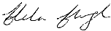
 | Duncan Haworth | Chair of Governors
 | 
Date for Review: Sept 2024
September 2-024
September 2024

Key Personnel

Role | Name | Email | Telephone
Designated Safeguarding Lead (DSL)*/** | Helen Hough | head@woodfall.cheshire.sch.uk | 07795182962
Deputy DSL(s)*/** | Jane Bramham | deputy@woodfall.cheshire.sch,uk | 07817240534
Additional Deputy DSL | Kim Muir | kmuir@woodfall.cheshire.sch.uk | 01518325020
Headteacher* | Helen Hough | head@woodfall.cheshire.sch.uk | 07795182962
Online safety Co-ordinator | Chris Boot | cboot@woodfall.cheshire.sch.uk | 01518325020
Chair of Governors* | Duncan Haworth | dhaworth.governor@woodfall.cheshire.sch.uk | 07976654192
Safeguarding Governor/Trustee | Maxine Wellsbury/Laurie Lee | mwellsbury.governor@woodfall.cheshire.sch.uk  llee.governor@woodfall.cheshire.sch.uk | 01518325020

*Out of hours contact details will be made available to staff

**Any changes to key personnel/holiday/emergency contacts will be shared with the appropriate agencies and LA safeguarding boards/hubs

Contents

CHLD PROTECTION AND SAFEGUARDING POLICY

Subject | Page
Safeguarding Statement | 5
Terminology | 6
Safeguarding Legislation and Guidance | 6
Policy Principles, Aims and Values | 7
Safe Environment ie. Safe School, Safe Staff | 9
Roles and Responsibilities | 10
Confidentiality | 13
Recognising and Responding to Safeguarding Concerns | 13
Children Who Are Particularly Vulnerable | 18
Whistleblowing | 19
Allegations Against Staff | 19
Physical Intervention | 20
Confidentiality, Information Sharing and GDPR | 21
Photographing children | 22
Complaints and Compliments | 22
Additional information for parents | 23
Policy Links | 24
APPENDICES

App 1. Categories of Abuse | 24
App 2. Anti-Bullying / Cyberbullying | 28
App 3. Racist Incidents | 28
App 4. Radicalisation and Extremism | 28
App 5. Domestic Abuse (including Operation Encompass) | 31
App 6. Exploitation (including CSE, CCE and County Lines) | 32
App 7. Female Genital Mutilation | 35
App 8. Forced Marriage | 36
App 9. Honour Based Abuse | 37
App 10. One Chance Rule | 37
App 11. Mental Health | 37
App 12. Private Fostering Arrangements | 38
App 13. Looked After Children & Previously Looked After Children | 38
App 14. Children Missing Education | 39
App 15. Child on Child Abuse (incl Sexual Violence, Sexual Harassment and HSB) | 39
App 16. Online Safety | 42
App 17. Youth Produced Sexual Imagery (Sexting) | 44
App 18. Additional Resources | 45
App 19. Safeguarding – Key Points | 46
App 20. Essential contacts | 48
App 21. Assessment triangle | 49
App 22. Roles and responsibilities of single point of contact (radicalisation and extremism) | 50

Safeguarding Statement

Woodfall Primary and Nursery School recognises our moral and statutory responsibility to safeguard and promote the welfare of all pupils and expects all staff, governors, and volunteers to share this commitment.
We recognise that all children, regardless of age, disability, SEND, gender reassignment, race, religion or belief, sex, or sexual orientation have an equal right to protection from all types of harm or abuse.
We endeavour to provide a safe and welcoming environment where children are respected and valued.
We are alert to the signs of abuse and neglect and follow our procedures to ensure that children receive effective support, protection, and justice.
We listen to our pupils and take seriously what they tell us, children are aware of the adults they can talk to if they have a concern.
When there are concerns for a child’s welfare, we may need to share information and work in partnership with other agencies.
We will ensure concerns are discussed with parents/carers first unless we have reason to believe that by doing so would be contrary to the child’s welfare.
This Child Protection and Safeguarding policy underpins and guides our safeguarding procedures and protocols.

“A good child protection system should be concerned with a child’s journey through the system from needing to receiving help, keeping a clear focus on children’s best interests throughout.”
Page 12 Munro Review of Child Protection Report; the child’s journey –
Professor Eileen Munro February 2012 Children’s Commissioner for England June 2010

“It’s all about relationships. We are talking about dealing with people with problems, with painful stuff. You have to know someone to trust them. They must be reliable and be there for you if you are going to be able to talk about the things you don’t want to. The things that scare you.”
Parent and family prospective on safeguarding relation with Children’s Service; the Children’s Commissioner for England June 2010

“Schools have a duty to ensure that their functions in relation to the conduct of the school are exercised with a view to safeguarding and promoting welfare of the children who are its pupils.”
Education Act 2002 Section 175

“Children become the victims or beneficiaries of adult actions”
Hugh Cunningham 2006

Terminology

Safeguarding and promoting the welfare of children is defined as:

- protecting children from maltreatment,
- preventing impairment of children's mental and physical health or development,
- ensuring that children grow up in circumstances consistent with the provision of safe and effective care; and
- taking action to enable all children to have the best outcomes.
Child Protection is a part of safeguarding and promoting welfare. It refers to the activity that is undertaken to protect specific children who are suffering, or are likely to suffer, significant harm.

Staff refers to all those working for or on behalf of the school, full or part time, temporary or permanent, in either a paid or voluntary capacity.

Child/pupil includes everyone under the age of 18 or 25 if a care leaver.

Parents refers to birth parents and other adults who are in a parenting role, for example stepparents, foster carers, adoptive parents and LA corporate parents.

CME refers to Children missing from Education.
Safeguarding Legislation and Guidance

- Safeguarding Legislation and Guidance

- Safeguarding Legislation and Guidance

- Safeguarding Legislation and Guidance

- Safeguarding Legislation and Guidance

- Safeguarding Legislation and Guidance

The following safeguarding legislation and guidance has been considered when drafting this policy:

- Keeping Children Safe in Education, 2023;
- Working Together to Safeguard Children, 2018
- The Statutory Framework for the Early Years Foundation Stage
- Education Act 2002 Section 175 (maintained schools only)
- Education Act 2002 Section 157 (Independent schools incl Academies and CTC's)
- The Education (Independent School Standards) (England) Regulations 2003
- The Safeguarding Vulnerable Groups Act 2006
- Teachers’ Standards (Guidance for school leaders, school staff and governing bodies)
- Information Sharing 2018
- What to do if you’re worried a child is being abused
- Filtering and monitoring standards in schools and colleges (DfE)

Policy Principles, Aims and Values

The welfare of the child is paramount:
- All children regardless of age, gender, culture, language, race, ability, sexual identity or religion have equal rights to protection, safeguarding and opportunities.
- We recognise that all adults, including temporary staff, volunteers and governors, all have a duty to protect our pupils from harm and have an equal responsibility to act on any suspicion or disclosure that may suggest a child is at risk of harm.
- All staff believe that our school should provide a caring, positive, safe and stimulating environment that promotes the social, physical, mental wellbeing and moral development of the individual child.
- Pupils and staff involved in child protection issues will receive appropriate support and supervision.

This policy aims to:
- Raise the awareness of all staff of the need to safeguard children.
- Provide all staff with guidance on the procedures they should adopt in the event that they suspect a child/young person may be experiencing, or be at risk of experiencing, harm. Including (by DSL/DDSL) consideration to the use of appropriate assessments, resources and agency support.
- Provide an environment in which children and young people feel safe, secure, valued, and respected, and that they will be listened to should they make a disclosure.
- Raise awareness that abuse can be both Familial and/or Contextual; and abusers can be both adult/s to child/ren or child/ren to child/ren.
- Demonstrate the school’s commitment with regard to safeguarding and child protection to pupils, parents and other partners.
- Provide a systematic means of monitoring children known or thought to be at risk of harm.
- To emphasise the need for high levels of communication between staff and the designated safeguarding leads internally and with external agencies and partners, including our contribution to assessments, referrals, and support plans.
- To develop and promote effective working relationships with other partnership agencies, particularly Childrens Social Care, Police and Health.
- Support the child’s development in ways that will foster security, confidence, and independence.
- Ensure that all staff working within our school who have substantial access to children have been checked as to their suitability, including verification of their identity, qualifications, and a satisfactory DBS check (according to guidance), and a single central record is kept for audit.
- Provide clarity and expectations on professional behaviours and code of conduct including lone working requirements.

Supporting and Protecting Children:
- We recognise that a child who is abused or witnesses’ violence may feel helpless and humiliated and could experience barriers to making a disclosure. We understand that the behaviour of a child in these circumstances may range from that which is perceived to be normal to aggressive or withdrawn as well as exhibiting signs of mental health problems. We understand the impact on a child’s mental health, behaviour, and education from familial and/or contextual abuse. School may not only provide stability in the lives of children who have been abused or who are at risk of harm, but it plays a significant part in the prevention of harm to our children.

Our school will support all children by:
- encouraging self-esteem and self-assertiveness, through the curriculum as well as our relationships, whilst not condoning aggression or bullying (incl. cyber bullying).
- promoting a caring, safe, and positive environment within the school and providing children with good lines of communication with trusted adults, supportive friends and an ethos of protection.
- responding sympathetically to any requests for time out to deal with distress and anxiety.
- offering details of helplines, counselling, or other avenues of external support.
- liaising and working together with all other settings, support services and those agencies involved in the safeguarding of children.
- notifying Childrens’ Social Care as soon as there is a significant concern.
- ensuring appropriate information is shared confidentially at key transition points in a child’s journey to ensure continuous support (incl. school medical records).
- children are taught to understand and manage risk through our Personal, Social, Health and Economic (PSHE) education and Relationship and Sex Education (RSE) and through all aspects of school life. This includes online safety.
- by accessing and utilising the necessary resources, guidance and toolkits to support the identification of children requiring mental health support, support services and assessments.
- reassuring victims that they are being taken seriously and that they will be supported and kept safe.

The school community will protect children by:
- working to establish and maintain an ethos where children feel secure, are encouraged to talk, and are always listened to.
- ensuring that all children know there are adults in the school whom they can approach if they are worried or in difficulty.
- including regular consultation with children, parents, and staff, gathering their voice.
- including safeguarding across the curriculum to equip children with the skills they need to stay safe from harm and to know to whom they should turn for help; in particular this will include anti-bullying work, information about child on child abuse (sexual harassment and sexual violence, consent), online-safety, road safety, pedestrian and cycle training; provide focused activities to prepare key year groups for transition to new settings and/or key stages e.g. more personal safety/independent travel
- ensuring all staff, pupils and parents are aware of school guidance for their use of mobile technology and the safeguarding issues around the use of mobile technologies, including the use of social media and their associated risks.

Safe environment

The school is committed to creating and maintaining a safe learning environment for children and young people, identifying where there are child welfare concerns and taking action to address them in partnership with families and other agencies. This policy reflects the policies of Cheshire West’s Safeguarding Children Partnership, Cheshire West SCP and is in line with Working Together to Safeguard Children (2018) and Keeping Children Safe in Education (2023)

The school will also contribute through the curriculum by developing children’s understanding, awareness and promoting their resilience by providing a safe environment within schools.

To provide a safe environment we will ensure that staff, governors, school, and parents:

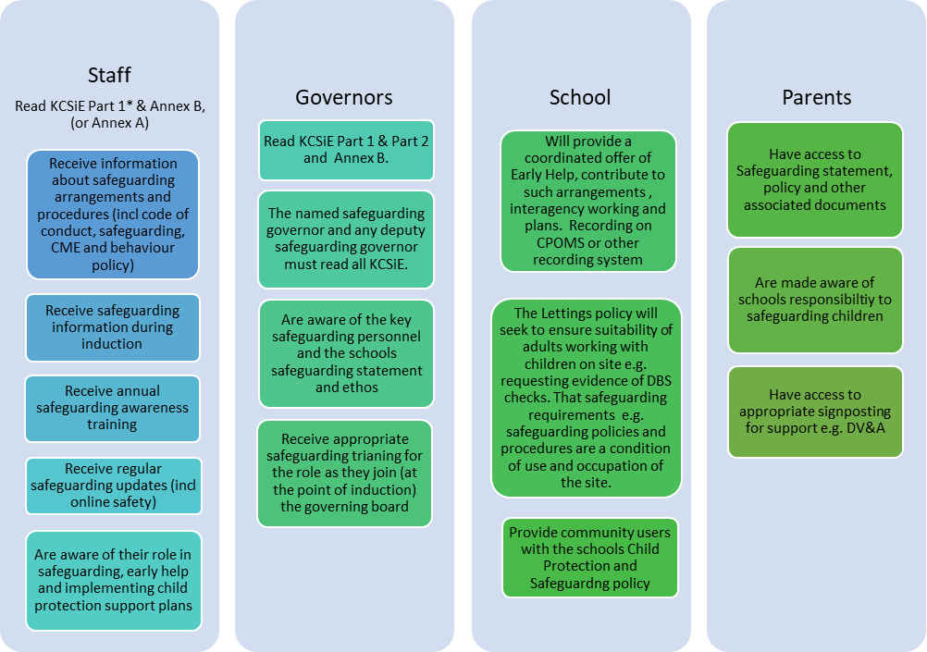

Roles and Responsibilities

We will follow the statutory guidance as set out in the latest Keeping Children Safe in Education (and associated documents and guidance), adhering to the roles, responsibilities and expectations identified for:
- Governing bodies, proprietors and management committees.
- The headteacher
- The designated safeguarding lead.
- The deputy designated safeguarding lead/s
- Staff
Keeping Children Safe in Education

Governing bodies, proprietors, and management committees:

All members of The Governing Body understand and fulfil their responsibilities, namely, to ensure that there is a Child Protection and Safeguarding Policy together with a Staff Behaviour policy (Code of Conduct).

Governing bodies and proprietors should ensure that all governors and trustees receive appropriate safeguarding and child protection (including online) training at induction. This training should equip them with the knowledge to provide strategic challenge to test and assure themselves that the safeguarding policies and procedures in place in schools and colleges are effective and support the delivery of a robust whole school approach to safeguarding. Their training should be regularly updated.

Roles and responsibilities will include:

- Child protection, safeguarding, recruitment and managing allegations policies and procedures, including the staff behaviour policy (code of conduct), are consistent with the Local Authority and statutory requirements, are reviewed annually and that the Child Protection and Safeguarding policy is publicly available on the school website or by other means.
- Ensures that all staff including temporary staff and volunteers are provided with the school’s Child Protection and Safeguarding policy and staff Code of Conduct.
- All staff have read Keeping Children Safe in Education Part 1* and Annex B and those mechanisms are in place to assist staff in understanding and discharging their roles and responsibilities as set out in the guidance. (* or Annex A if not working directly with children)
- The school operates a safer recruitment procedure that includes statutory checks on staff, disqualification by association regulations and by ensuring that there is at least one person on every recruitment panel who has completed safer recruitment training.
- The school has procedures for dealing with allegations of abuse against staff (including the Headteacher), supply staff, volunteers and against other children and that a referral is made to the DBS if a person in regulated activity has been dismissed or removed due to safeguarding concerns or would have had they not resigned.
- A member of the Governing Body/Board, usually the Chair, is nominated to liaise with the Local Authority on Child Protection issues and in the event of an allegation of abuse made against the Headteacher.
- A member of the senior leadership team has been appointed as the Designated Safeguarding Lead (DSL) by the Governing Body/Board who will take lead responsibility.
- On appointment, the DSL and deputy(ies) undertake appropriate Level 3 identified training offered by the Cheshire West Safeguarding Children Partnership every two years.
- All other staff undertake safeguarding training every 3 years and an update at least annually.
- At least one member of the governing body has completed safer recruitment training.
- Children are taught about safeguarding (including online safety) as part of a broad and balanced curriculum covering relevant issues to meet their needs, including children who have recognised vulnerabilities.
- Appropriate safeguarding responses are in place for children who go missing (are absent) from education.
- Appropriate online filtering and monitoring systems are in place.
- Enhanced DBS checks at the appropriate level are in place for all Governors.
- Any weaknesses in Child Protection are remedied immediately.

The Headteacher:

The Headteacher will support the governing body, designated safeguarding lead, deputies, staff and volunteers to fulfil their roles and responsibilities.

Roles and responsibilities will include:

- Ensuring the Child Protection and Safeguarding policy and procedures are implemented and followed by all staff.
- Enabling sufficient time, training, support, resources, including cover arrangements where necessary, is allocated to the DSL and deputy(ies) DSL(s) to carry out their roles effectively,
- Supporting and promoting a safeguarding culture and ethos in school so that child/ren’s wishes and feelings are taken into account when determining what action to take and what services to provide.
- Ensuring systems are in place for children to express their views and give feedback.
- Following the whistleblowing policy and procedures if an allegation is made against a member of staff, supply staff or volunteer staff, including liaising with the Local Authority Designated Officer (LADO) and referring anyone who has harmed or may pose a risk to a child to the Disclosure and Barring Service.
- That pupils are provided with opportunities throughout the curriculum to learn about safeguarding, including keeping themselves safe online.

The Designated Safeguarding Lead (DSL):

The designated safeguarding lead should take lead responsibility for safeguarding and child protection (including online safety). This should be explicit in the role holder’s job description. (They must be a member of SLT).

Roles and responsibilities will include:

- Availability – being available during school hours.
- Manage referrals – to e.g., Childrens Social Care, Channel programme, Disclosure and Barring service, the Police.
- Working with others – e.g., a point of contact with safeguarding partners, a source of support and advice for staff, to promote supportive engagement with parents and/or carers and the SLT/Governing body.
- Information sharing and managing the child protection/safeguarding files.
- Raising Safeguarding and Child Protection Awareness.
- Updating training, knowledge and skills required to carry out the role of DSL e.g., additional training such as neglect, exploitation etc.
- Providing support to staff.
- Holding and sharing information.
- Overseeing and acting upon filtering and monitoring reports and checks to these systems.

The Deputy Designated Safeguarding Lead/s (DDSL):

Is/ are trained to the same standard as the Designated Safeguarding Lead and, in the absence of the DSL, carries out those functions necessary to ensure the ongoing safety and protection of pupils. In the event of the long-term absence of the DSL the deputy will assume all of the functions above.
Whilst the activities of the designated safeguarding lead can be delegated to appropriately trained deputies, the ultimate lead responsibility for child protection, as set out above, remains with the designated safeguarding lead, this lead responsibility should not be delegated.

Staff:
Roles and responsibilities will include:

- maintaining an attitude of ‘it could happen here’ where safeguarding is concerned.
- identifying concerns early, provide help for children, promote children’s welfare, and prevent concerns from escalating.
- to provide a safe environment in which children can learn.
- knowing what to do if a child tells them they are being abused, exploited, or neglected.
- being able to reassure victims that they are being taken seriously and that they will be supported and kept safe.
- recognising the barriers for children when wanting to make a disclosure (verbal or non-verbal).
- identifying children who may benefit from early help, (providing support as soon as a problem emerges) and the part they play in these support plans.
- raising any concerns for a child following the school’s safeguarding policies and procedures.
- being aware of local authority referral processes and supporting social workers and other agencies following any referral.
- adhering to Teachers’ Standards 2012 - that teacher (which includes headteachers) should safeguard children’s wellbeing and maintain public trust in the teaching profession as part of their professional duties.
- Being aware of systems within school which support safeguarding e.g., safeguarding policy, behaviour policy, code of conduct, CME, online filtering, and monitoring.
- Attending regular safeguarding and child protection training.
- Recognising that children missing or absent from education can act as a vital warning sign to a range of safeguarding issues including neglect, sexual abuse and child sexual and criminal exploitation.

Confidentiality

- Our school recognises that in order to effectively meet a child’s needs, safeguard their welfare and protect them from harm, the school must contribute to inter-agency working in line with Working Together to Safeguard Children (2018) and share information between professionals and agencies where there are concerns.
- All staff must be aware that they have a professional responsibility to share information with other agencies in order to safeguard children and that the Data Protection Act 2018 is not a barrier to sharing information where the failure to do so would place a child at risk of harm.
- All staff must be aware that they cannot promise a child to keep secrets which might compromise the child’s safety or wellbeing.
- However, we also recognise that all matters relating to child protection are personal to children and families. Therefore, in this respect they are confidential and the Headteacher or DSLs will only disclose information about a child to other members of staff on a need-to-know basis.
- We will always undertake to share our intention to refer a child to I-ART with their parents /carers unless to do so could put the child at greater risk of harm or impede a criminal investigation.
- In line with KCSiE, all children’s safeguarding files will be kept confidential and stored securely. Safeguarding files will be kept separate from pupils’ schools’ files on CPOMS (which requires passwords and authentication codes.

Recognising and Responding to Safeguarding Concerns

Recognising:

Any child, in any family, in any school, could become a victim of abuse. Staff should always maintain an attitude of “It could happen here”. We also recognise that abuse, neglect, and safeguarding issues are complex and are rarely standalone events that can be covered by one definition or label. Staff are aware that in most cases multiple issues will overlap one another.

- Abuse and neglect are forms of maltreatment of a child. Somebody may abuse or neglect a child by inflicting harm or by failing to act to prevent harm. Children may be abused in the family or in an institutional or community setting by those known to them or, more rarely, by others. Abuse can take place wholly online, or technology may be used to facilitate offline abuse. They may be abused by an adult or adults or by another child or children.
- Abuse and Neglect may also take place outside of the home, contextual safeguarding, and this may include (but not limited to), sexual exploitation, criminal exploitation, serious youth violence and/or radicalisation.
- Staff are aware that behaviours linked to drug taking, alcohol abuse, truanting and sexting put children in danger and that safeguarding issues can manifest themselves via child-on-child abuse.
Further information about the four categories of abuse; physical, emotional, sexual and neglect, (familial and contextual) and indicators that a child may be being abused can be found in appendices 1 - 17 and in Keeping Children Safe in Education Part 1/Annex A/Annex B. There are also a number of specific safeguarding concerns that we recognise our pupils may experience.

- child missing or absent from education.  - child missing from home or care.  - child sexual exploitation (CSE), child criminal exploitation (CCE)  - bullying including cyberbullying  - domestic abuse  - drugs  - fabricated or induced illness  - faith abuse  - female genital mutilation (FGM)  - forced marriage.  - gangs and youth violence | - gender-based violence/violence against women and girls (VAWG)  - mental health difficulties  - private fostering  - radicalisation  - youth produced sexual imagery (sexting)  - teenage relationship abuse  - trafficking  - child on child abuse  - up skirting  - serious violence  - sexual harassment

- There will be occasions when staff may suspect that a pupil may be at risk but have no ‘real’ evidence. The pupil’s behaviour may have changed, their artwork could be bizarre, and they may write stories or poetry that reveal confusion or distress, or physical or inconclusive signs may have been noticed.
- We recognise that the signs may be due to a variety of factors, for example, a parent has moved out, a pet has died, a grandparent is very ill, or an accident has occurred. However, they may also indicate a child is being abused or is in need of safeguarding.
- In these circumstances staff will try to give the child the opportunity to talk. It is fine for staff to ask the pupil if they are OK or if they can help in any way.

Further information on the different types of safeguarding concerns and schools’ response can be found in the Appendices section –

App 1. Categories of Abuse | 22
App 2. Anti-Bullying / Cyberbullying | 26
App 3. Racist Incidents | 26
App 4. Radicalisation and Extremism | 26
App 5. Domestic Abuse (including Operation Encompass) | 29
App 6. Exploitation (including CSE, CCE and County Lines) | 30
App 7. Female Genital Mutilation | 33
App 8. Forced Marriage | 34
App 9. Honour Based Abuse | 35
App 10. One Chance Rule | 35
App 11. Mental Health | 35
App 12. Private Fostering Arrangements | 36
App 13. Looked After Children & Previously Looked After Children | 36
App 14. Children Missing Education | 37
App 15. Child on Child Abuse (incl Sexual Violence, Sexual Harassment and HSB) | 37
App 16. Online Safety | 40
App 17. Youth Produced Sexual Imagery (Sexting) | 42
App 18. Additional Resources | 43
App 19. Safeguarding – Key Points | 44
App 20. Essential contacts | 46
App 21. Assessment triangle | 47
App 22. Roles and responsibilities of single point of contact (radicalisation and extremism) | 48

Responding:

- Following an initial conversation with the pupil, if the member of staff remains concerned, they should discuss their concerns with the DSL and put them in writing, see FLOW CHART A.

Records should include:
• a clear and comprehensive summary of the concern.
• details of how the concern was followed up and resolved.
• a note of any action taken, decisions reached and the outcome.

- If the pupil does begin to reveal that they are being harmed, staff should follow the advice in FLOW CHART A and in the table below ‘pupil making a disclosure’.
- All concerns however small must be recorded and shared with the DSL as this information could provide the ‘missing’ piece of the bigger picture of the lived experience for the child.

FLOW CHART A

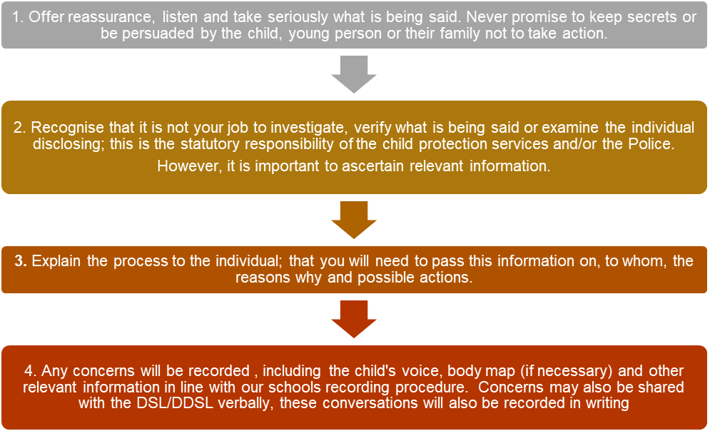

If a pupil discloses to a member of staff
- We recognise that it takes a lot of courage for a child to disclose they are being abused. They may feel ashamed, guilty, or scared, their abuser may have threatened that something will happen if they tell, they may have lost all trust in adults or believe that what has happened is their fault. Sometimes, they may not be aware that what is happening is abuse.
- A child who makes a disclosure may have to tell their story on a number of subsequent occasions to the police and/or social workers. Therefore, it is vital that their first experience of talking to a trusted adult is a positive one.
During their conversation with the pupil staff will:
- listen to what the child has to say and allow them to speak freely.
- remain calm and not overreact or act shocked or disgusted – the pupil may stop talking if they feel they are upsetting the listener.
- reassure the child that it is not their fault and that they have done the right thing in telling someone.
- not be afraid of silences – staff must remember how difficult it is for the pupil and allow them time to talk.
- take what the child is disclosing seriously.
- ask open questions and avoid asking leading questions.
- avoid jumping to conclusions, speculation or make accusations.
- not automatically offer any physical touch as comfort. It may be anything but comforting to a child who is being abused.
- avoid admonishing the child for not disclosing sooner. Saying things such as ‘I do wish you had told me about it when it started’ may be the staff member’s way of being supportive but may be interpreted by the child to mean they have done something wrong.
- tell the child what will happen next, that they cannot keep secrets and that information will be shared to ensure the right level of support is given.

Notifying Parents
- The school will normally seek to discuss any concerns about a pupil with their parents. This must be handled sensitively and normally the DSL/DDSL will make contact with the parent in the event of a concern, suspicion or disclosure of abuse that the child has been harmed in some way.
- However, if the school believes that notifying parents could increase the risk to the child or exacerbate the problem, I-ART will be contacted first e.g., familial sexual abuse.
- Where there are concerns about FGM, forced marriage or so-called honour-based abuse, parents should not be informed a referral is being made, as to do so may place the child at a significantly increased risk.

Making a referral
- Concerns about a child or a disclosure should be immediately raised with the DSL who will help decide whether a referral to I-ART or other support is appropriate in accordance with the SCP Continuum of Need.
- If school are uncertain about whether a concern raised should be referred to I-ART, a consultation will be sought with the Local Authority SCIE team to seek further support and guidance. If there is a TAF in place, the school will consult the TAF advisor.
- If a referral is needed, the DSL should make this rapidly and have the necessary systems in place to enable this to happen. However, anyone can make a referral and if for any reason a staff member thinks a referral is appropriate and one hasn’t been made, they can, and should, consider making a referral themselves.
- The child (subject to their age and understanding) and the parents will be told that a referral is being made, unless to do so would increase the risk to the child.
- If after a referral the child’s situation does not appear to be improving, the designated safeguarding lead (or the person that made the referral) should press for re-consideration to ensure their concerns have been addressed, and most importantly the child’s situation improves (using the escalation and resolution policy).
- If a child is in immediate danger or is at risk of harm a referral should be made to I-ART and/or the police immediately. Anybody can make a referral.
- Where referrals are not made by the DSL, the DSL should be informed as soon as possible.

Supporting our Staff
- We recognise that staff working in the school who have become involved with a child who has suffered harm or appears to be likely to suffer harm may find the situation stressful and upsetting.
- We will support such staff by providing an opportunity to talk through their anxieties with the DSLs and to seek further support as appropriate.

Early Intervention and Prevention within Safeguarding

All school staff need to be aware of their responsibility to raise any concerns they have about a child as early as possible in order to prevent the situation worsening. This may present as a change in a child’s behaviour, appearance or from a conversation with the family about home conditions, financial difficulties, speech and language, toileting issues etc. Where this concern does not identify a safeguarding issue but could lead to more serious concerns if left, staff need to follow the procedures set out in the Team around the Family (TAF) guidance to fulfil their duties at Universal Plus and Partnership Plus on the Continuum of Need. This may involve signposting to or involving more appropriate agencies for support and may involve the school acting as Lead Person on a child’s TAF. In the event of complex needs, a referral to Integrated access and referral team (I-ART) for support from the Early Help and Prevention service should be made.

Children who are particularly vulnerable

Woodfall Primary and Nursery School recognises that some children are more vulnerable to abuse, neglect and contextual safeguarding concerns and that additional barriers exist when recognising abuse for some children. We understand that this increase in risk is due more to societal attitudes and assumptions or child protection procedures which fail to acknowledge children’s diverse circumstances, rather than the individual child’s personality, impairment, or circumstances.
In some cases, possible indicators of abuse such as a child’s mood, behaviour or injury might be assumed to relate to the child’s impairment or disability rather than giving a cause for concern. Or a focus may be on the child’s disability, special educational needs, or situation without consideration of the full picture. In other cases, such as bullying, the child may be disproportionately impacted by the behaviour without outwardly showing any signs that they are experiencing it.
Some children may also find it harder to disclose abuse due to communication barriers, lack of access to a trusted adult or not being aware that what they are experiencing is abuse.

Any child may benefit from early help, but all school and college staff should be particularly alert to the potential need for early help for a child who:
- is disabled and has specific additional needs.
- has special educational needs (whether or not they have a statutory education, health and care plan).
- is a young carer.
- is showing signs of being drawn in to anti-social or criminal behaviour, including gang involvement and association with organised crime groups.
- is frequently missing/goes missing from care or from home.
- is misusing drugs or alcohol themselves.
- is at risk of modern slavery, trafficking or exploitation.
- is in a family circumstance presenting challenges for the child, such as substance abuse, adult mental health problems or domestic abuse.
- has returned home to their family from care.
- is showing early signs of abuse and/or neglect.
- is at risk of being radicalised or exploited.
- is a privately fostered child.
- has an imprisoned parent.
- is experiencing mental health, wellbeing difficulties.
- is persistently absent from education (including persistently absent for part of the school day).
- is at risk of ‘honour’ based abuse such as FGM or Forced Marriage

Whistleblowing

We recognise that children cannot be expected to raise concerns in an environment where staff fail to do so.

All staff should be aware of their duty to raise concerns, where they exist, about the management of child protection, which may include the attitude or actions of colleagues, poor or unsafe practice and potential failures in the school’s safeguarding arrangements. If it becomes necessary to consult outside the school, they should speak in the first instance, to the LADO following the Whistleblowing Policy.

Whistleblowing in relation to the Headteacher should be made to the Chair of the Governing Body whose contact details are readily available to staff (please see the back of our adult toilet doors for details).

(N.B. - The NSPCC whistleblowing helpline is available for staff who do not feel able to raise concerns regarding child protection failures internally. Staff can call: 0800 028 0285 line is available from 8:00 AM to 8:00 PM, Monday to Friday and email: help@nspcc.org.uk )

Allegations against staff

All school staff should take care not to place themselves in a vulnerable position with a child. It is always advisable for interviews or work with individual children or parents to be conducted in view of other adults. Guidance about conduct and safe practice, including safe use of mobile phones by staff and volunteers will be given at induction.

In line with KCSiE part 4 guidelines,

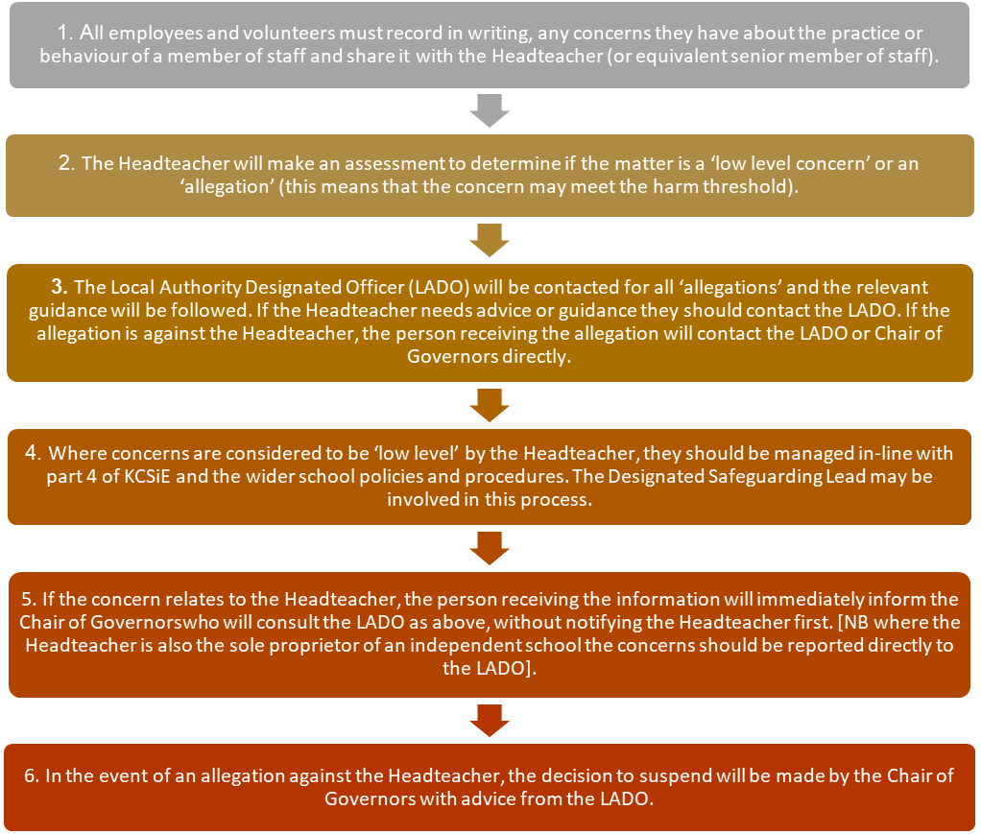

Suspension of the member of staff, excluding the Headteacher, against whom an allegation has been made, needs careful consideration, and the Headteacher will seek the advice of the LADO and an HR Consultant in making this decision.

Staff, parents, and governors are reminded that publication of material that may lead to the identification of a teacher who is the subject of an allegation is prohibited by law. Publication includes verbal conversations or writing including content placed on social media sites.

Physical Intervention

We acknowledge that staff must only ever use physical intervention as a last resort, when a child is endangering him/herself or others, and that at all times it must be the minimal force necessary to prevent injury to another person.
Such events should be recorded and signed by a witness.
Staff who are likely to need to use physical intervention will be appropriately trained.
We understand that physical intervention of a nature which causes injury or distress to a child may be considered under child protection or disciplinary procedures.
We recognise that touch is appropriate in the context or working with children, and all staff have been given ‘Safe Practice’ guidance to ensure they are clear about their professional boundary.
Confidentiality, Sharing Information and GDPR

All staff will understand that child protection issues warrant a high level of confidentiality, not only out of respect for the pupil and staff involved but also to ensure that information being released into the public domain does not compromise evidence.
Staff should be proactive in sharing as early as possible to help identify, assess and respond to risks or concerns about the safety and welfare of children, whether this is when problems are first emerging, or where a child is already known to local authority children’s social care.
Staff should only discuss concerns with the DSL, Headteacher/principal, or chair of governors (depending on who is the subject of the concern). That person will then decide who else needs to have the information and they will disseminate it on a ‘need-to-know’ basis.
However, following a number of cases where senior leaders in school had failed to act upon concerns raised by staff, Keeping Children Safe in Education emphasises that any member of staff can contact children’s social care if they are concerned about a child.
Child protection information will be stored and handled in line with the Data Protection Act 2018 and HM Government Information Sharing and Advice for practitioners providing safeguarding services to children, young people, parents and carers, July 2018. School will consider where appropriate information sharing prior to the child’s formal transfer to their new setting, this could also include key staff from their new setting to be invited to meetings e.g., Child Protection, Core group or Team Around a Family (with consent of parents and professionals).
At the point a child formally transfers to their new setting, their safeguarding file will be transferred securely in line with GDPR expectations as soon as possible, but within 5 working days.

Information sharing is guided by the following principles:
- necessary and proportionate
- relevant
- adequate
- accurate
- timely
- secure

Fears about sharing information cannot be allowed to stand in the way of the need to promote the welfare and protect the safety of children.
Woodfall Primary and Nursery School will ensure that images of children used within publications, publicity and on the website has written parental consent prior to any images being taken and used. This consent will be obtained in line with school’s annual data collection process.

Photographing Children

The vast majority of people who take or view photographs or videos of children do so for entirely innocent, understandable and acceptable reasons. We acknowledge, however, that some people abuse children through taking, using or circulating images.

Staff and Volunteers

- Parental consent will be sought (annually and as part of our September data collection and checking exercise)
- Staff and volunteers must seek the authorisation of the Head Teacher prior to taking photographs/ videos of children and must only use school equipment unless given specific authorisation by the Head Teacher.
- The use of cameras on mobile phones or the downloading of images onto any internet site is forbidden
- Only the pupil’s first name will be used with an image
- It will be ensured that pupils are appropriately dressed before images are taken
- Pupils are encouraged to tell us if they are worried or unsure about any photographs that are taken of them.

The Guidance for Safer working Practices for Adults who work with Children and Young People provides detailed guidance on the taking of photographs and storage of images.

Parents or Members of the Public

We understand that parents like to take photos of or video record their children in the school production, or at sports day, or school presentations. This is a normal part of family life, and we will not discourage parents from celebrating their child’s successes.

However, if there are Health and Safety issues associated with this (e.g. the use of a flash when taking photos could distract or dazzle the child, causing an accident), we will encourage parents to use film or settings on their camera that do not require flash.

We will not allow other people, including staff, to photograph or film pupils during a school activity without parental permission. This includes the use of cameras on mobile phones or any other device.

We will not allow images of pupils to be used on school websites, publicity, or press releases, including social networking sites, without express permission from the parent, and if we do obtain such permission, we will not identify individual children by name.

The school cannot, however, be held accountable for the use of photographs or video footage taken by parents or members of the public at school functions where parental permission has been given.
Complaints and Compliments

Our complaints procedure will be followed where a pupil or parent raises a concern about poor practice towards a pupil that initially does not reach the threshold for child protection action. Poor practice examples include unfairly singling out a pupil, using sarcasm or humiliation as a form of control, bullying or belittling a pupil or discriminating against them in some way. Complaints are managed by senior staff e.g. the Headteacher and Governors. An explanation of the complaints procedure is included in:

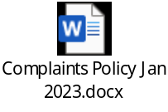

Complaints from staff are dealt with under the school’s Complaints, Disciplinary and Grievance procedures.
Additional information for parents

Contact arrangements and Parental responsibility

We recognise that a relationship breakdown can be very distressing for all involved, however, any contact arrangements must be agreed outside of school and school should not be put in a position where they are placed in the middle of contact disputes. We aim to make the school environment a calm and safe place for your children, as well as the whole school community, and would be unable to do this if we are placed at the centre of disputes. School is also unable to prevent anyone with parental responsibility (PR) from picking up a child from school unless there is a court order in place stating that the person with PR is not allowed to do so, although the school will attempt to seek permission from the primary carer before releasing the child.

Policy Links

This policy also links to our policies on:

- Behaviour  - Staff Behaviour Policy / Code of Conduct  - Whistleblowing  - Anti-bullying  - Health & Safety  - Allegations against staff  - Parental concerns  - Attendance  - Curriculum  - PSHE  - Teaching and Learning | - Administration of medicines  - Drug Education  - Relationships and Sex Education  - Physical intervention  - Online Safety, including staff use of mobile phones  - Risk Assessment  - Recruitment and Selection  - Child Sexual Exploitation  - Intimate Care  - Radicalisation and Extremism  - Data Protection/GDPR Guidance

Appendices

- Categories of Abuse

Categories of Abuse:

- Physical Abuse
- Emotional Abuse (including Domestic Abuse)
- Sexual Abuse (including child sexual exploitation)
- Neglect
Signs of Abuse in Children:

The following non-specific signs may indicate something is wrong:
- Significant change in behaviour
- Extreme anger or sadness
- Aggressive and attention-needing behaviour
- Suspicious bruises with unsatisfactory explanations
- Lack of self-esteem
- Self-injury
- Depression and/or anxiousness
- Age-inappropriate sexual behaviour
- Child Sexual Exploitation
- Criminality
- Substance abuse
- Mental health problems
- Poor attendance
Risk Indicators

The factors described in this section are frequently found in cases of child abuse. Their presence is not proof that abuse has occurred, but:

- Must be regarded as indicators of the possibility of significant harm
- Justifies the need for careful assessment and discussion with designated / named / lead person, manager, (or in the absence of all those individuals, an experienced colleague)
- May require consultation with and / or referral to Children’s Services
The absence of such indicators does not mean that abuse or neglect has not occurred.

In an abusive relationship the child may:

- Appear frightened of the parent/s
- Act in a way that is inappropriate to her/his age and development (though full account needs to be taken of different patterns of development and different ethnic groups)
The parent or carer may:

- Persistently avoid child health promotion services and treatment of the child’s episodic illnesses
- Have unrealistic expectations of the child
- Frequently complain about/to the child and may fail to provide attention or praise (high criticism/low warmth environment)
- Be absent or misusing substances
- Persistently refuse to allow access on home visits
- Be involved in domestic abuse
Staff should be aware of the potential risk to children when individuals, previously known or suspected to have abused children, move into the household.

Recognising Physical Abuse

The following are often regarded as indicators of concern:

- An explanation which is inconsistent with an injury
- Several different explanations provided for an injury
- Unexplained delay in seeking treatment
- The parents/carers are uninterested or undisturbed by an accident or injury
- Parents are absent without good reason when their child is presented for treatment
- Repeated presentation of minor injuries (which may represent a “cry for help” and if ignored could lead to a more serious injury)
- Family use of different doctors and A&E departments
- Reluctance to give information or mention previous injuries
Bruising

Children can have accidental bruising, but the following must be considered as non-accidental unless there is evidence, or an adequate explanation provided:

- Any bruising to a pre-crawling or pre-walking baby
- Bruising in or around the mouth, particularly in small babies which may indicate force feeding
- Two simultaneous bruised eyes, without bruising to the forehead, (rarely accidental, though a single bruised eye can be accidental or abusive)
- Repeated or multiple bruising on the head or on sites unlikely to be injured accidentally
- Variation in colour possibly indicating injuries caused at different times
- The outline of an object used e.g. belt marks, handprints or a hairbrush
- Bruising or tears around, or behind, the earlobe/s indicating injury by pulling or twisting
- Bruising around the face
- Grasp marks on small children
- Bruising on the arms, buttocks and thighs may be an indicator of sexual abuse
Mongolian Blue Spot: Bruising in non-mobile children is rare and may indicate abuse or neglect. Birth marks, especially Mongolian Blue Spots, can mimic bruising. Mongolian Blue Spot can be identified (see below), however if in any doubt as to the cause of the bruise refer to local authority guidance and consultation.

- Areas of skin hyperpigmentation – flat, not raised, swollen or inflamed
- Not painful to touch
- Usually present at birth/ develop soon afterwards
- Will not change in shape or colour within a few days
- Normally uniform blue/ grey in colour across the mark
- Common in African, Middle Eastern, Mediterranean and Asian children
- While most occur at the lower back and buttocks, they can appear anywhere (e.g. back of shoulder or limb). Scalp/ face rarely affected
- Can be single/ multiple, vary in size, but mostly few centimetres diameter
- Gradually fade over many year

Bite Marks

Bite marks can leave clear impressions of the teeth. Human bite marks are oval or crescent shaped. Those over 3 cm in diameter are more likely to have been caused by an adult or older child.
A medical opinion should be sought where there is any doubt over the origin of the bite.

Burns and Scalds

It can be difficult to distinguish between accidental and non-accidental burns and scalds and will always require experienced medical opinion. Any burn with a clear outline may be suspicious e.g.:

- Circular burns from cigarettes (but may be friction burns if along the bony protuberance of the spine)
- Linear burns from hot metal rods or electrical fire elements
- Burns of uniform depth over a large area
- Scalds that have a line indicating immersion or poured liquid (a child getting into hot water is his/her own accord will struggle to get out and cause splash marks)
- Old scars indicating previous burns/scalds which did not have appropriate treatment or adequate explanation
Scalds to the buttocks of a small child, particularly in the absence of burns to the feet, are indicative of dipping into a hot liquid or bath.

Fractures

Fractures may cause pain, swelling and discolouration over a bone or joint. Non-mobile children rarely sustain fractures.

There are grounds for concern if:

- The history provided is vague, non-existent or inconsistent with the fracture type
- There are associated old fractures
- Medical attention is sought after a period of delay when the fracture has caused symptoms such as swelling, pain or loss of movement
- There is an unexplained fracture in the first year of life

Scars

A large number of scars or scars of different sizes or ages, or on different parts of the body, may suggest abuse.

Recognising Emotional Abuse

Emotional abuse may be difficult to recognise, as the signs are usually behavioural rather than physical. The manifestations of emotional abuse might also indicate the presence of other kinds of abuse. The indicators of emotional abuse are often also associated with other forms of abuse.
The following may be indicators of emotional abuse:

- Developmental delay
- Abnormal attachment between a child and parent/carer e.g. anxious, indiscriminate or not attachment
- Indiscriminate attachment or failure to attach
- Aggressive behaviour towards others
- Scapegoated within the family
- Frozen watchfulness, particularly in pre-school children
- Low self-esteem and lack of confidence
- Withdrawn or seen as a “loner” – difficulty relating to others
Recognising Signs of Sexual Abuse

Boys and girls of all ages may be sexually abused and are frequently scared to say anything due to guilt and/or fear. This is particularly difficult for a child to talk about, and full account should be taken of the cultural sensitivities of any individual child/family. Recognition can be difficult, unless the child discloses and is believed. There may be no physical signs and indications are likely to be emotional/behavioural.

Some behavioural indicators associated with this form of abuse are:

- Inappropriate sexualised conduct
- Sexually explicit behaviour, play or conversation, inappropriate to the child’s age
- Continual and inappropriate or excessive masturbation
- Self-harm (including eating disorder), self-mutilation and suicide attempts
- Involvement in prostitution or indiscriminate choice of sexual partners
- An anxious unwillingness to remove clothes e.g. for sports events (but this may be related to cultural norms or physical difficulties)
Some physical indicators associated with this form of abuse are:

- Pain or itching of genital area
- Blood on underclothes
- Pregnancy in a younger girl where the identity of the father is not disclosed
- Physical symptoms such as injuries to the genital or anal area, bruising to buttocks, abdomen and thighs, sexually transmitted disease, presence of semen on vagina, anus, external genitalia or clothing
Recognising Neglect

Evidence of neglect is built up over a period of time and can cover different aspects of parenting. Indicators include:

- Failure by parents or carers to meet the basic essential needs e.g. adequate food, clothes, warmth, hygiene and medical care
- A child seen to be listless, apathetic and irresponsive with no apparent medical cause
- Failure of child to grow within normal expected pattern, with accompanying weight loss
- Child thrives away from home environment
- Child frequently absent from school
- Child left with adults who are intoxicated or violent
- Child abandoned or left alone for excessive periods
2. Anti-Bullying/Cyberbullying

Our school policy on anti-bullying is set out in a separate document and acknowledges that to allow or condone bullying may lead to consideration under child protection procedures. This includes all forms e.g. cyber, racist, homophobic and gender related bullying. We keep a record of known bullying incidents which is shared with and analysed by the governing body. All staff are aware that children with SEND and / or differences/perceived differences are more susceptible to being bullied / victims of child abuse.

If the bullying is particularly serious, or the anti-bullying procedures are seen to be ineffective, the Headteacher and the DSL will consider implementing child protection procedures.

The subject of bullying is addressed at regular intervals in PHSE education.
3. Racist Incidents

Our policy on racist incidents is set out separately and acknowledges that repeated racist incidents or a single serious incident may lead to consideration under child protection procedures. We keep a record of racist incidents and provide them to Ofsted on request.
4. Radicalisation and Extremism

The Prevent Duty for England and Wales (2015) under section 26 of the Counter-Terrorism and Security Act 2015 places a duty on education and other children’s services to have due regard to the need to prevent people from being drawn into terrorism.

Extremism is defined as ‘vocal or active opposition to fundamental British values, including democracy, the rule of law, individual liberty and mutual respect and tolerance of different faiths and beliefs. We also include in our definition of extremism calls for the death of members of our armed forces, whether in this country or overseas.

Some children are at risk of being radicalised; adopting beliefs and engaging in activities which are harmful, criminal or dangerous.
School is clear that exploitation of vulnerable children and radicalisation should be viewed as a safeguarding concern and follows the Department for Education guidance for schools and childcare providers on preventing children and young people from being drawn into terrorism.

School seeks to protect children and young people against the messages of all violent extremism including, but not restricted to, those linked to Islamist ideology, or to Far Right / Neo Nazi / White Supremacist ideology, Irish Nationalist and Loyalist paramilitary groups, and extremist Animal Rights movements.

School staff receive training to help identify early signs of radicalisation and extremism. Indicators of vulnerability to radicalisation are in detailed in the Appendix section.

Opportunities are provided in the curriculum to enable pupils to discuss issues of religion, ethnicity and culture and the school follows the DfE advice Promoting Fundamental British Values as part of SMSC (spiritual, moral, social and cultural education) in Schools (2014).

The school governors, the Headteacher and the Designated Safeguarding Lead (DSL) will assess the level of risk within the school and put actions in place to reduce that risk. Risk assessment may include the use of school premises by external agencies, anti-bullying policy and other issues specific to the school’s profile, community and philosophy.

When any member of staff has concerns that a pupil may be at risk of radicalisation or involvement in terrorism, they should speak with the DSL. They should then follow normal safeguarding procedures e.g. a referral to Channel. If the matter is urgent, then the Police must be contacted by dialling 999. In non-urgent cases where police advice is sought then dial 101. The Department of Education has also set up a dedicated telephone helpline for staff and governors to raise concerns around Prevent (020 7340 7264).

Indicators Of Vulnerability to Radicalisation

- Radicalisation refers to the process by which a person comes to support terrorism and forms of extremism leading to terrorism.
- Extremism is defined by the Government in the Prevent Strategy as:
Vocal or active opposition to fundamental British values, including democracy, the rule of law, individual liberty and mutual respect and tolerance of different faiths and beliefs. We also include in our definition of extremism calls for the death of members of our armed forces, whether in this country or overseas.

- Extremism is defined by the Crown Prosecution Service as:
The demonstration of unacceptable behaviour by using any means or medium to express views which:

- Encourage, justify or glorify terrorist violence in furtherance of particular beliefs.
- Seek to provoke others to terrorist acts.
- Encourage other serious criminal activity or seek to provoke others to serious criminal acts; or
- Foster hatred which might lead to inter-community violence in the UK.
There is no such thing as a “typical extremist”: those who become involved in extremist actions come from a range of backgrounds and experiences, and most individuals, even those who hold radical views, do not become involved in violent extremist activity.

Pupils may become susceptible to radicalisation through a range of social, personal and environmental factors - it is known that violent extremists exploit vulnerabilities in individuals to drive a wedge between them and their families and communities. It is vital that school staff are able to recognise those vulnerabilities.

Indicators of vulnerability include:

- Identity Crisis – the student / pupil is distanced from their cultural / religious heritage and experiences discomfort about their place in society.
- Personal Crisis – the student / pupil may be experiencing family tensions; a sense of isolation; and low self-esteem; they may have dissociated from their existing friendship group and become involved with a new and different group of friends; they may be searching for answers to questions about identity, faith and belonging.
- Personal Circumstances – migration; local community tensions; and events affecting the student / pupil’s country or region of origin may contribute to a sense of grievance that is triggered by personal experience of racism or discrimination or aspects of Government policy.
- Unmet Aspirations – the student / pupil may have perceptions of injustice; a feeling of failure; rejection of civic life.
- Experiences of Criminality – which may include involvement with criminal groups, imprisonment, and poor resettlement / reintegration.
- Special Educational Need – students / pupils may experience difficulties with social interaction, empathy with others, understanding the consequences of their actions and awareness of the motivations of others.
However, this list is not exhaustive, nor does it mean that all young people experiencing the above are at risk of radicalisation for the purposes of violent extremism.

More critical risk factors could include:

- Being in contact with extremist recruiters.
- Accessing violent extremist websites, especially those with a social networking element.
- Possessing or accessing violent extremist literature.
- Using extremist narratives and a global ideology to explain personal disadvantage.
- Justifying the use of violence to solve societal issues.
- Joining or seeking to join extremist organisations; and
- Significant changes to appearance and / or behaviour.
- Experiencing a high level of social isolation resulting in issues of identity crisis and / or personal crisis.
The Prevent duty ensures schools and colleges have ‘due regard’ to the need to prevent people from being draw into terrorism.

Channel is the voluntary, confidential support programme which focuses on providing support at an early stage to individuals that have been identified as being vulnerable to radicalisation. Prevent referrals may be passed to the multi-agency Channel panel to determine whether individuals require support.

The Prevent Duty can be accessed via this link. (School specific para’s 57-76)
Summary of The Prevent Duty for Schools and Childcare Providers (June 2015)
The Prevent Duty, for Further Education Institutions
Guidance on Channel https://www.gov.uk/government/publications/channel-guidance
Further information can be obtained from the Home Office website.
5. Domestic Abuse (incl Operation Encompass)

The behaviour of a person (“A”) towards another person (“B”) is “domestic abuse” if—

- A and B are each aged 16 or over and are personally connected to each other, and
the behaviour is abusive.

The behaviour is “abusive” if it consists of any of the following—
(a)physical or sexual abuse;
(b)violent or threatening behaviour;
(c)controlling or coercive behaviour;
(d)economic abuse;
(e)psychological, emotional or other abuse;

and it does not matter whether the behaviour consists of a single incident or a course of conduct.

(“Economic abuse” means any behaviour that has a substantial adverse effect on B’s ability to—
(a)acquire, use or maintain money or other property, or
(b)obtain goods or services.)

For the purposes of the domestic abuse Act 2021 A’s behaviour may be behaviour “towards” B despite the fact that it consists of conduct directed at another person (for example, B’s child).

The Domestic abuse Act 2021 introduces the first ever statutory definition of domestic abuse and recognises the impact of domestic abuse on children, as victims in their own right, if they see, hear or experience the effects of abuse. The statutory definition of domestic abuse, based on the previous cross-government definition, ensures that different types of relationships are captured, including ex-partners and family members. The definition captures a range of different abusive behaviours, including physical, emotional and economic abuse and coercive and controlling behaviour. Both the person who is carrying out the behaviour and the person to whom the behaviour is directed towards must be aged 16 or over and they must be “personally connected” (as defined in section 2 of the 2021 Act).

Domestic abuse represents one quarter of all violent crime. It is actual or threatened physical, emotional, psychological, financial (economic) or sexual abuse. It involves the use of power and control by one person over another. It occurs regardless of race, ethnicity, gender, class, sexuality, age, and religion, mental or physical ability. Domestic abuse can also involve other types of abuse.
We use the term domestic abuse to reflect that a number of abusive and controlling behaviours are involved beyond violence.

How does it affect children?

Domestic abuse can encompass a wide range of behaviours and may be a single incident or a pattern of incidents. Children can be victims of domestic abuse. They may see, hear, or experience the effects of abuse at home and/or suffer domestic abuse in their own intimate relationships (teenage relationship abuse). All of which can have a detrimental and long-term impact on their health, well-being, development, and ability to learn. In some cases, children may blame themselves for the abuse or may have had to leave the family home as a result. Children who witness domestic abuse are at risk of significant harm.

What are the signs to look out for?

Children affected by domestic abuse reflect their distress in a variety of ways. They may change their usual behaviour and become withdrawn, tired, start to wet the bed and have behavioural difficulties. They may not want to leave their house or may become reluctant to return. Others will excel, using their time in your care as a way to escape from their home life. None of these signs are exclusive to domestic abuse so when you are considering changes in behaviours and concerns about a child, think about whether domestic abuse may be a factor.

Operation Encompass

Operation Encompass helps police and schools work together to provide emotional and practical help for children. Police will inform the ‘key adult’ within school if they have been called to an incident of domestic abuse, where there are children in the household before registration the next day.
6. Exploitation (incl Child Sex Exploitation, Child Criminal Exploitation & County Lines)

Both CSE and CCE are forms of abuse and both occur where an individual or group takes advantage of an imbalance in power to coerce, manipulate or deceive a child into sexual or criminal activity. This power imbalance could be due to age, gender, sexual identity, cognitive ability, physical strength, status, and /or access to economic or other resources. The abuse could be linked to an exchange for something the victim perceives that they need or want and/or will be to the financial benefit or other advantage (such as increase status) of the perpetrator or facilitator.

The abuse can be perpetrated by individuals or groups, males or females, and adults or children (who themselves may be experiencing exploitation). The abuse can be a one-off occurrence or a series of incidents over time and range from opportunistic to complex organised abuse. It may involve force and/or enticement-based methods of compliance and may, or may not, be accompanied by violence or threats of violence.

Victims can be exploited even when the activity appears consensual, and it should be noted exploitation as well as being physical can be facilitated and/or take place online. The experience of girls who are criminally exploited can be very different from boys, the indicators may not be the same and both boys and girls that are being criminally exploited may be at higher risk of sexual exploitation.

Any concerns that a child is being or is at risk of being sexually or criminally exploited should be passed without delay to the DSL. We aware there is a clear link between regular school absence/truanting, CSE and CCE. Staff should consider a child to be at potential CSE/CCE risk in the case of regular school absence/truanting and make reasonable enquiries with the child and parents to assess this risk.

The DSL will use the Cheshire Contextual Safeguarding Assessment tool on all occasions when there is a concern that a child is being or is at risk of being sexually or criminally exploited or where indicators have been observed that are consistent with a child who is being or who is at risk of being sexually or criminally exploited. These assessments will indicate to the DSL the potential level of risk and a referral to I-ART will be made for discussion at the Contextual Safeguarding Hub. If the DSL is in any doubt, they will contact the SCiE team.

School is aware that a child often is not able to recognise the coercive nature of the abuse and does not see themselves as a victim. As a consequence, the child may resent what they perceive as interference by staff. However, staff must act on their concerns as they would for any other type of abuse.

School includes the risks of sexual and criminal exploitation in the PHSE and RSE curriculum. Pupils will be informed of the grooming process and how to protect themselves from people who may potentially be intent on causing harm. They will be supported in terms of recognising and assessing risk in relation to CSE/CCE, including online, and knowing how and where to get help.

The following list of indicators is not exhaustive or definitive, but it does highlight common signs which can assist professionals in identifying children or young people who may be victims of sexual or criminal exploitation.

Signs include:

- going missing from home or school
- regular school absence/truanting
- underage sexual activity
- inappropriate sexual or sexualised behaviour
- sexually risky behaviour, 'swapping' sex
- repeat sexually transmitted infections
- in girls, repeat pregnancy, abortions, miscarriage
- receiving unexplained gifts or gifts from unknown sources
- having multiple mobile phones and worrying about losing contact via mobile
- online safety concerns such as youth produced sexual imagery or being coerced into sharing explicit images.
- having unaffordable new things (clothes, mobile) or expensive habits (alcohol, drugs)
- changes in the way they dress
- going to hotels or other unusual locations to meet friends
- seen at known places of concern
- moving around the country, appearing in new towns or cities, not knowing where they are
- getting in/out of different cars driven by unknown adults
- having older boyfriends or girlfriends
- contact with known perpetrators
- involved in abusive relationships, intimidated and fearful of certain people or situations
- hanging out with groups of older people, or anti-social groups, or with other vulnerable peers
- associating with other young people involved in sexual exploitation
- recruiting other young people to exploitative situations
- truancy, exclusion, disengagement with school, opting out of education altogether
- unexplained changes in behaviour or personality (chaotic, aggressive, sexual)
- mood swings, volatile behaviour, emotional distress
- self-harming, suicidal thoughts, suicide attempts, overdosing, eating disorders
- drug or alcohol misuse
- getting involved in crime
- police involvement, police records
- involved in gangs, gang fights, gang membership
- injuries from physical assault, physical restraint, sexual assault.
Child Criminal Exploitation can include children being forced or manipulated into transporting drugs or money through county lines, working in cannabis factories, shoplifting or pickpocketing. They can also be forced or manipulated into committing vehicle crime or threatening/committing serious violence to others.

County lines is a term used to describe gangs and organised criminal networks involved in the exporting of illegal drugs (primarily crack cocaine and heroin) into one or more importing areas (within the UK), using dedicated mobile phone lines or other form of ‘deal line.’

Exploitation is an integral part of the county lines offending model, with children and vulnerable adults being exploited to move (and store) drugs and money. The same grooming models used to coerce, intimidate and abuse individuals for sexual and criminal exploitation are also used for grooming vulnerable individuals for county lines.

CSE is a form of child sexual abuse. CSE can occur over time or be a one-off occurrence. CSE can affect any child, who has been coerced into engaging in sexual activities. This includes 16 and 17-year-olds who can legally consent to have sex.

Sexual abuse may involve physical contact, including assault by penetration (for example, rape or oral sex) or nonpenetrative acts such as masturbation, kissing, rubbing, and touching outside clothing. It may include non-contact activities, such as involving children in the production of sexual images, forcing children to look at sexual images or watch sexual activities, encouraging children to behave in sexually inappropriate ways or grooming a child in preparation for abuse including via the internet.

For further information on signs of a child’s involvement in sexual exploitation: Child sexual exploitation: guide for practitioners.

For further information on County Lines: Criminal exploitation of children and vulnerable adults: county lines guidance
7. Female Genital Mutilation (FGM)

It is essential that staff are aware of FGM practices and the need to look for signs, symptoms and other indicators of FGM. If a member of staff, in the course of their work, discovers that an act of FGM appears to have been carried out, the member of staff must report this to the Police.
Female Genital Mutilation (FGM) is illegal in England and Wales under the FGM Act 2003 (“the 2003 Act”). It is a form of child abuse and violence against women. FGM comprises all procedures involving partial or total removal of the external female genitalia for non-medical reasons.
Section 5B of the 2003 Act1 introduces a mandatory reporting duty which requires regulated health and social care professionals and teachers in England and Wales to report ‘known’ cases of FGM in under 18s which they identify in the course of their professional work to the police. The duty came into force on 31 October 2015.

What is FGM?

It involves procedures that intentionally alter/injure the female genital organs for non-medical reasons.

4 types of procedure:

Type 1 Clitoridectomy – partial/total removal of clitoris
Type 2 Excision – partial/total removal of clitoris and labia minora
Type 3 Infibulation entrance to vagina is narrowed by repositioning the inner/outer labia
Type 4 all other procedures that may include: pricking, piercing, incising, cauterising and scraping the genital area.

Why is it carried out?

Belief that:

- FGM brings status/respect to the girl – social acceptance for marriage
- Preserves a girl’s virginity
- Part of being a woman / rite of passage
- Upholds family honour
- Cleanses and purifies the girl
- Gives a sense of belonging to the community
- Fulfils a religious requirement
- Perpetuates a custom/tradition
- Helps girls be clean / hygienic
- Is cosmetically desirable
- Mistakenly believed to make childbirth easier
Is FGM legal?

FGM is internationally recognised as a violation of human rights of girls and women. Female Genital Mutilation (FGM) is illegal in England and Wales under the FGM Act (2003). It is a form of child abuse and violence against women. A mandatory reporting duty requires teachers to report ‘known’ cases of FGM in under 18s, which are identified in the course of their professional work, to the police .

The duty applies to all persons in our School who is employed or engaged to carry out ‘teaching work’ in the school, whether or not they have qualified teacher status. The duty applies to the individual who becomes aware of the case to make a report. It should not be transferred to the Designated Safeguarding Lead; however the DSL should be informed.
If a teacher is informed by a girl under 18 that an act of FGM has been carried out on her, or a teacher observes physical signs which appear to show that an act of FGM has been carried out on a girl under 18, and they have no reason to believe the act was necessary for the girl’s physical or mental health or for purposes connected with labour or birth, the teacher should personally make a report to the police force in which the girl resides by calling 101. The report should be made by the close of the next working day.

School staff are trained to be aware of risk indicators of FGM identified in this section of the Appendix. Concerns about FGM outside of the mandatory reporting duty should be reported as per our school’s child protection procedures. Staff should be particularly alert to suspicions or concerns expressed by female pupils about going on a long holiday during the summer vacation period. There should also be consideration of potential risk to other girls in the family and practicing community.
Where there is a risk to life or likelihood of serious immediate harm the teacher should report the case immediately to the police, including dialling 999 if appropriate.

There are no circumstances in which a teacher or other member of staff should examine a girl.

Circumstances and occurrences that may point to FGM happening are:

- Child talking about getting ready for a special ceremony
- Family taking a long trip abroad
- Child’s family being from one of the ‘at risk’ communities for FGM (Kenya, Somalia, Sudan, Sierra Leon, Egypt, Nigeria, Eritrea as well as non-African communities including Yemeni, Afghani, Kurdistan, Indonesia and Pakistan)
- Knowledge that the child’s sibling has undergone FGM
- Child talks about going abroad to be ‘cut’ or to prepare for marriage
Signs that may indicate a child has undergone FGM:

- Prolonged absence from school and other activities
- Behaviour changes on return from a holiday abroad, such as being withdrawn and appearing subdued
- Bladder or menstrual problems
- Finding it difficult to sit still and looking uncomfortable
- Complaining about pain between the legs
- Mentioning something somebody did to them that they are not allowed to talk about
- Secretive behaviour, including isolating themselves from the group
- Reluctance to take part in physical activity
- Repeated urinal tract infection
- Disclosure
The ‘One Chance’ rule
As with Forced Marriage (outlined below) there is the ‘One Chance’ rule. It is essential that settings /schools/colleges take action without delay and make a referral to I-ART.
8. Forced Marriage

A forced marriage is a marriage in which one or both people do not (or in cases of people with learning disabilities cannot) consent to the marriage but are coerced into it. Coercion may include physical, psychological, financial, sexual and emotional pressure. It may also involve physical or sexual violence and abuse.

Forced marriage is an appalling and indefensible practice and is recognised in the UK as a form of violence against women and men, domestic/child abuse and a serious abuse of human rights. Since June 2014 forcing someone to marry has become a criminal offence in England and Wales under the Anti-Social Behaviour, Crime and Policing Act 2014.

A forced marriage is not the same as an arranged marriage which is common in several cultures. The families of both spouses take a leading role in arranging the marriage but the choice of whether or not to accept the arrangement remains with the prospective spouses.

School staff should never attempt to intervene directly as a school or through a third party. Contact should be made with I-ART.
9. So-called Honour-based Abuse

So-called Honour based abuse (HBA) can be described as a collection of practices, which are used to control behaviour within families or other social groups to protect perceived cultural and religious beliefs and/or honour. Such abuse can occur when perpetrators perceive that a relative has shamed the family and/or community by breaking their honour code.

Honour based abuse might be committed against people who:

- become involved with a boyfriend or girlfriend from a different culture or religion.
- want to get out of an arranged marriage.
- want to get out of a forced marriage.
- wear clothes or take part in activities that might not be considered traditional within a particular culture.
It is a violation of human rights and may be a form of domestic and/or sexual abuse. There is no, and cannot be, honour or justification for abusing the human rights of others.
10. One Chance Rule

All staff are aware of the ‘One Chance’ Rule’ in relation to forced marriage, FGM and HBV. Staff recognise they may only have one chance’ to speak to a pupil who is a potential victim and have just one chance to save a life.
School is aware that if the victim is not offered support following disclosure that the ‘One Chance’ opportunity may be lost. Therefore, all staff are aware of their responsibilities and obligations when they become aware of potential forced marriage, FGM and HBV cases.
11. Mental Health

Staff will be aware that mental health problems can, in some cases, be an indicator that a child has suffered or is at risk of suffering abuse, neglect or exploitation. Whilst school recognise that only appropriately trained professionals can diagnose mental health problems; staff are able to make day to day observations of children and identify such behaviour that may suggest they are experiencing a mental health problem or be at risk of developing one.
How traumatic Adverse Childhood Experiences and experiences of abuse and neglect can impact on a child’s mental health, behaviour and education through to adolescence and adulthood will be covered in safeguarding awareness training and updates. If staff have a concern about a child’s mental health that is also a safeguarding concern, they will share this with the DSL or deputy. School will also refer to the mental health and behaviour in schools’ guidance.

When supporting children experiencing mental health difficulties school will explore resources such as:

Senior Mental Health Lead Training
Promoting children and young people’s mental health and wellbeing
Rise Above: Resources for School from Public Health England #esafety
Every Interaction Matters Webinar
Wellbeing for Education Recovery
Preventing and Tackling Bullying
Promoting and supporting mental health and wellbeing in schools and colleges
12. Private Fostering Arrangements

A private fostering arrangement occurs when someone other than a parent or close relative cares for a child for a period of 28 days or more, with the agreement of the child’s parents. It applies to children under the age of 16 or 18 if the child is disabled. Children looked after by the local authority or who are place in residential schools, children’s homes or hospitals are not considered to be privately fostered.

Private fostering occurs in all cultures, including British culture and children may be privately fostered at any age.

School recognise that most privately fostered children remain safe and well but are aware that safeguarding concerns have been raised in some cases. Therefore, all staff are alert to possible safeguarding issues, including the possibility that the child has been trafficked into the country.

By law, a parent, private foster carer or other persons involved in making a private fostering arrangement must notify children’s services as soon as possible. However, where a member of staff becomes aware that a pupil may be in a private fostering arrangement, they will raise this will the DSL and the DSL will notify I-ART of the circumstances.
13. Looked after children and previously looked after children

The most common reason for children becoming looked after is as a result of abuse and neglect. Our school will ensure that staff have the necessary skills and understanding to keep looked after/previously looked after children safe. Appropriate staff have information about a child’s looked after legal status and care arrangements, including the level of authority delegated to the carer by the authority looking after the child and contact arrangements with birth parents or those with parental responsibility.

The designated teacher for looked after children and the DSL have details of the child’s social worker and the name and contact details of the Local Authority’s virtual school head for children in care.
The designated teacher for looked after children works with the virtual school head to discuss how Pupil Premium Plus funding can be best used to support the progress of looked after children in the school and meet the needs in the child’s personal education plan. The designated teacher will follow the statutory guidance ‘Promoting the education of Looked After Children’.
14. Children Missing Education

Attendance, absence and exclusions are closely monitored. The school will hold more than one emergency contact number for pupils and students where reasonably possible. A child going missing or absent from education is a potential indicator of abuse and neglect, including sexual abuse and sexual or criminal exploitation.

The DSL will monitor unauthorised absences and take appropriate action including notifying the local authority particularly where children go missing on repeat occasions and/or are missing for periods during the school day in conjunction with ‘Children Missing Education: Statutory Guidance for Local Authorities’.

Staff must be alert to signs of children at risk of travelling to conflict zones, female genital mutilation and forced marriage.
15. Child on Child Abuse (including Sexual Violence, Sexual Harassment and HSB)

The DSL, Governing Body/Board and Head Teacher will take due regard to Part 5, KCSiE
In most instances, the conduct of pupils towards each other will be covered by our behaviour policy. However, some allegations may be of such a serious nature that they may raise safeguarding concerns. School recognises that children are capable of abusing their peers. It will not be passed off as ‘banter’ or ‘part of growing up’.

The forms of child-on-child abuse are outlined below:

- domestic abuse – an incident or pattern of actual or threatened acts of physical, sexual, financial and/or emotional abuse, perpetrated by an adolescent against a current or former dating partner regardless of gender or sexuality.
- bullying (including cyberbullying, prejudice-based and discriminatory bullying).
- child sexual exploitation – children under the age of 18 may be sexually abused in the context of exploitative relationships, contexts and situations by peers who are also under 18.
- harmful sexual behaviour – children and young people presenting with sexual behaviours that are outside of developmentally ‘normative’ parameters and harmful to themselves and others
- upskirting – which typically involves taking a picture under a person’s clothing without them knowing, with the intention of viewing their genitals or buttocks to obtain sexual gratification, or cause the victim humiliation, distress or alarm.
- serious youth violence – any offence of most serious violence or weapon enabled crime, where the victim is aged 0-19’ i.e. murder, manslaughter, rape, wounding with intent and causing grievous bodily harm. ‘Youth violence’ is defined in the same way, but also includes assault with injury offences. All staff will receive training so that they are aware of indicators which may signal that children are at risk from or involved with serious violence and crime.
- initiation/hazing type violence and rituals (this could include activities involving harassment, abuse or humiliation used as a way of initiating a person into a group and may also include an online element); and
- consensual and non-consensual sharing of nudes and semi nudes’ images and or videos (also known as sexting or youth produced sexual imagery).
The term child-on-child abuse can refer to all of these definitions and a child may experience one or multiple facets of abuse at any one time. Therefore, our response will cut across these definitions and capture the complex web of their experiences.

There are also different gender issues that can be prevalent when dealing with child-on-child abuse (i.e. girls being sexually touched/assaulted, or boys being subjected to initiation/hazing type violence).

School aims to reduce the likelihood of child-on-child abuse through:

- the established ethos of respect, friendship, courtesy and kindness.
- high expectations of behaviour.
- clear consequences for unacceptable behaviour.
- providing a developmentally appropriate PSHE curriculum which develops pupils’ understanding of healthy relationships, acceptable behaviour, consent and keeping themselves safe.
- systems for any pupil to raise concerns with staff, knowing that they will be listened to, valued and believed.
- robust risk assessments and providing targeted work for pupils identified as being a potential risk to other pupils and those identified as being at risk.
Research indicates that young people rarely disclose child-on-child abuse and that if they do, it is likely to be to their friends. Therefore, School will also educate pupils in how to support their friends if they are concerned about them, that they should talk to a trusted adult in the school and what services they can contact for further advice.

Any concerns, disclosures or allegations of child-on-child abuse in any form should be referred to the DSL using the school’s child protection procedures as set out in this policy. Where a concern regarding child-on-child abuse has been disclosed to the DSL(s), advice and guidance will be sought from the SCiE team and appropriate referrals made, and where it is clear a crime has been committed or there is a risk of crime being committed, the Police will be contacted.

Working with external agencies, the school will respond to the unacceptable behaviour. If a pupil’s behaviour negatively impacts on the safety and welfare of other pupils, then safeguards will be put in place to promote the well-being of the pupils affected and the victim and perpetrator will be provided with support.

Sexual Harassment, Sexual Violence and Harmful Sexual Behaviour

The boundary between what is abusive and what is part of normal childhood or youthful experimentation can be blurred. The determination of whether behaviour is developmental, inappropriate or abusive will hinge around the related concepts of true consent, power imbalance and exploitation. Children’s sexual behaviour exists on a wide continuum, ranging from normal and developmentally expected to inappropriate, problematic, abusive and violent. Problematic, abusive and violent sexual behaviour is developmentally inappropriate and may cause developmental damage. This may include children and young people who exhibit a range of sexually problematic behaviour such as indecent exposure, obscene telephone calls, fetishism, bestiality and sexual abuse against adults, peers or children.

Staff should be vigilant to:

- bullying (including cyberbullying)
- physical abuse such as hitting, kicking, shaking, biting, hair pulling, or otherwise causing physical harm
- sexual violence and sexual harassment
- sexting (also known as youth produced sexual imagery)
- initiation/hazing type violence and rituals
- upskirting

Developmental Sexual Activity

Encompasses those actions that are to be expected from children and young people as they move from infancy through to an adult understanding of their physical, emotional and behavioural relationships with each other. Such sexual activity is essentially information gathering and experience testing. It is characterised by mutuality and of the seeking of consent.

Inappropriate Sexual Behaviour

Can be inappropriate socially, inappropriate to development, or both. In considering whether behaviour fits into this category, it is important to consider what negative effects it has on any of the parties involved and what concerns it raises about a child or young person. It should be recognised that some actions may be motivated by information seeking, but still cause significant upset, confusion, worry, physical damage, etc. It may also be that the behaviour is “acting out” which may derive from other sexual situations to which the child or young person has been exposed. If an act appears to have been inappropriate, there may still be a need for some form of behaviour management or intervention. For some children, educative inputs may be enough to address the behaviour.

Abusive sexual activity included any behaviour involving coercion, threats, aggression together with secrecy, or where one participant relies on an unequal power base. In order to more fully determine the nature of the incident the following factors should be given consideration.

The presence of exploitation in terms of:

Equality – consider differentials of physical, cognitive and emotional development, power and control and authority, passive and assertive tendencies
Consent – agreement including all the following:
- Understanding that is proposed based on age, maturity, development level, functioning and experience
- Knowledge of society’s standards for what is being proposed
- Awareness of potential consequences and alternatives
- Assumption that agreements or disagreements will be respected equally
- Voluntary decision
- Mental competence
Coercion – the young perpetrator who abuses may use techniques like bribing, manipulation and emotional threats of secondary gains and losses that is loss of love, friendship, etc. Some may use physical force, brutality or the threat of these regardless of victim resistance.

In evaluating sexual behaviour of children and young people, the above information should be used only as a guide. Further information and advice is available in the Cheshire West SCP Child-on child Abuse Guidance and Model policy Framework.
16. Online Safety

Our pupils increasingly use electronic equipment on a daily basis to access the internet and share content and images via social media sites such as Facebook, twitter, Instagram, Snapchat and ooVoo.

Unfortunately, some adults and other children use these technologies to harm children. The harm might range from sending hurtful or abusive texts or emails, to grooming and enticing children to engage in sexual behaviour such as webcam photography or face-to-face meetings. Pupils may also be distressed or harmed by accessing inappropriate material such as pornographic websites or those which promote extremist behaviour, criminal activity, suicide or eating disorders.

School has an online safety policy which explains how we try to keep pupils safe in school and how we respond to online safety incidents (See flowchart, on page 40).

School will also provide advice to parents when pupils are being asked to learn online at home and consider how best to safeguard both pupils and staff.

Pupils are taught about online safety throughout the curriculum and all staff receive online safety training which is regularly updated including an understanding of the expectations, applicable roles and responsibilities in relation to filtering and monitoring.

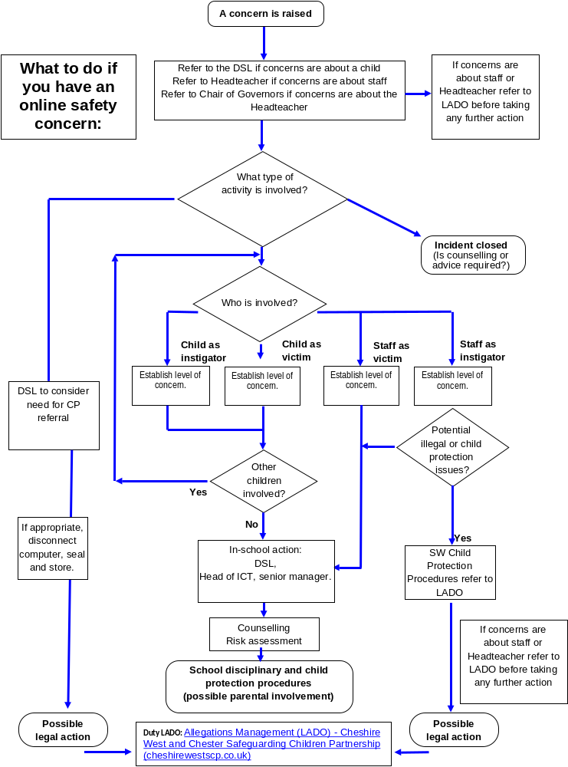

17. Youth produced sexual imagery (sexting)

The practice of children sharing images and videos via text message, email, social media or mobile messaging apps has become commonplace. However, this online technology has also given children the opportunity to produce and distribute sexual imagery in the form of photos and videos. Such imagery involving anyone under the age of 18 is illegal.

Youth produced sexual imagery refers to both images and videos where:

- A person under the age of 18 creates and shares sexual imagery of themselves with a peer under the age of 18.
- A person under the age of 18 shares sexual imagery created by another person under the age of 18 with a peer under the age of 18 or an adult.
- A person under the age of 18 is in possession of sexual imagery created by another person under the age of 18.
All incidents of this nature should be treated as a safeguarding concern and in line with the UKCIS guidance ‘Sexting in schools and colleges: responding to incidents and safeguarding young people’, and ‘Sharing nudes and semi-nudes: how to respond to an incident.’

Cases where sexual imagery of people under 18 has been shared by adults and where sexual imagery of a person of any age has been shared by an adult to a child is child sexual abuse and should be responded to accordingly.

If a member of staff becomes aware of an incident involving youth produced sexual imagery, they should follow the child protection procedures and refer to the DSL as soon as possible. The member of staff should confiscate the device involved and set it to flight mode or, if this is not possible, turn it off. Staff should not view, copy or print the youth produced sexual imagery.

The DSL should hold an initial review meeting with appropriate school staff and subsequent interviews with the children involved (if appropriate). Parents should be informed at an early stage and involved in the process unless there is reason to believe that involving parents would put the child at risk of harm. At any point in the process if there is concern a young person has been harmed or is at risk of harm a referral should be made to I-ART and/or the Police as appropriate.

Immediate referral at the initial review stage should be made to the I-ART/Police if:

- The incident involves an adult.
- There is good reason to believe that a young person has been coerced, blackmailed or groomed or if there are concerns about their capacity to consent (for example, owing to special education needs).
- What you know about the imagery suggests the content depicts sexual acts which are unusual for the child’s development stage or are violent.
- The imagery involves sexual acts.
- The imagery involves anyone aged 12 or under.
- There is reason to believe a child is at immediate risk of harm owing to the sharing of the imagery, for example the child is presenting as suicidal or self-harming.
If none of the above apply then the DSL will use their professional judgement to assess the risk to pupils involved and may decide, with input from the Headteacher, to respond to the incident without escalation to I-ART or the police. Such decisions will be recorded.

In applying judgement, the DSL will consider if:

- there is a significant age difference between the sender/receiver.
- there is any coercion or encouragement beyond the sender/receiver.
- the imagery was shared and received with the knowledge of the child in the imagery.
- the child is more vulnerable than usual i.e. at risk.
- there is a significant impact on the children involved.
- the image is of a severe or extreme nature.
- the child involved understands consent.
- the situation is isolated or if the image been more widely distributed.
- there other circumstances relating to either the sender or recipient that may add cause for concern i.e. difficult home circumstances.
- the children have been involved in incidents relating to youth produced imagery before.
If any of these circumstances are present the situation will be escalated according to our child protection procedures, including reporting to the police or I-ART. Otherwise, the situation will be managed within the school.

The DSL will record all incidents of youth produced sexual imagery, including both the actions taken, actions not taken, reasons for doing so and the resolution in line with safeguarding recording procedure
18. Additional Resources

Further advice on child protection is available from:

NSPCC: http://www.nspcc.org.uk/

Childline: http://www.childline.org.uk/pages/home.aspx

Anti-Bullying Alliance: http://anti-bullyingalliance.org.uk/

Beat Bullying: http://www.beatbullying.org/

Childnet International –making the internet a great and safe place for children. Includes resources for professionals and parents http://www.childnet.com/

Thinkuknow (includes resources for professionals and parents) https://www.thinkuknow.co.uk/

Safer Internet Centre http://www.saferinternet.org.uk/

Provision for transgender pupils: Guidance for maintained schools and academies in England on provision for transgender pupils November 2022
19. Safeguarding Children – Key Points

All adults in charge of or in contact with children or young people should know what to do if they suspect that someone is being physically, emotionally or sexually abused or neglected, or if someone tells them that this is happening. Ensure that you are familiar with the Safeguarding Policy; copies of which are located on our School Website. On request you will be provided with a printed copy.

In addition, the following key points give a guide on what to do and not to do.

1. Always stop and listen straight away to someone who wants to tell you about incidents or suspicions of abuse.

2. Make a note of what was said or observed as soon as possible and pass to the Designated Safeguarding Lead (Helen Hough 07795182962) at your earliest opportunity.

3. Never make a promise that you will keep what is said confidential or secret. If you are told about abuse you have a responsibility to tell the right people to get something done about it. You should explain that if you are going to be told something very important that needs to be sorted out, you will need to tell the people who can sort it out, but that you will only tell the people who absolutely have to know.

4. Do not ask leading questions that might give your own ideas of what might have happened, e.g. "did he do X to you?” Just ask, "what do you want to tell me?” or “Is there anything else you want to say?”

5. Immediately tell the Designated Safeguarding Lead unless they are the subject of the accusation. Don’t tell other adults or young people what you have been told. If someone has made an accusation to you or you have concerns about the Head Teacher, you should report your concerns to the Chair of Governors (Duncan Haworth 07976654192).

6. Discuss with the Designated Safeguarding Lead whether any steps need to be taken to protect the person who has told you about the abuse.

7. Never attempt to carry out an investigation of suspected or alleged abuse by interviewing people etc. Children’s Social Care and police officers are the people who have the authority to do this. You could cause more damage and endanger possible criminal proceedings. It is your duty to refer concerns on, not investigate.

8. As soon as possible (and certainly the same day) the Designated Lead for safeguarding should refer the matter to the Integrated Access and referral team (I-ART) if a child is at risk of or suffering or likely to suffer significant harm. Follow their instructions about what to do next. They will set up any necessary investigations. That is their statutory job. In the case of an allegation against an adult that works with children, the Head teacher, or the Chair of Governors where the allegation is against the Head Teacher, should refer the matter to The Local Authority Designated Officer (DO).

9. Never think abuse is impossible in your organisation or assume that an accusation against someone you know well and trust is bound to be wrong.

10. Children and young people often tell other young people, rather than staff or other adults about abuse. Therefore you may hear an allegation from another child. This should be acted upon in exactly the same manner as outlined above.

20. Essential contacts

Role | Contact Details
Designated Safeguarding Lead | Helen Hough – head@woodfall.cheshire.sch.uk 07795182962
Headteacher | Helen Hough – head@woodfall.cheshire.sch.uk 07795182962
Nominated Governor for Safeguarding | Maxine Wellsbury –  mwellsbury.governor@woodfall.cheshire.sch.uk and Laurie Lee lwilson.governor@woodfall.cheshire.sch.uk
Chair of Governors | Duncan Haworth – dhaworth.governor@woodfall.cheshire.sch.uk
Deputy Designated Safeguarding Lead | Jane Bramham – deputy@woodfall.cheshire.sch.uk
Named Local Authority Designated Officer (LADO) | Paul Jenkins - https://www.cheshirewestlscb.org.uk/policy-and-procedures/allegations-management-lado/
Local Authority Safeguarding Children in Education Officer (SCiE) | (delete as appropriate – Susie Sheasby - Chester and Chester Rural, Vicki Thomason – Ellesmere Port and Neston, Pam Beech – Northwich and Winsford.)
Safeguarding Children in Education Manager (SCiE) | Kerry Williams – Kerry.williams@cheshirewestandchester.gov.uk
Local Authority Legal Services Helpline
Local Authority Human Resources | Louise Odger – louise.odger@cheshirewestandchester.gov.uk
Integrated access and Referral Team  8.30-5pm Mon-Thurs  8.30-4.30 Fri | 0300 123 7047
Emergency Duty Team  (Out of hours)  4.30pm-8am Mon-Thurs  From 4pm Friday  24hours weekends and bank holidays | 01244 977 277
TAF Advisor | Jayne Ford – jayne.ford@cheshirewestandchester.gov.uk
Safeguarding Children Partnership | www.cheshirewestscp.org.uk  0151 356 6494
School Health Advisor
CAMHS
Cheshire Police | 0845 458 0000 or 101 for non emergencies  999 in case of emergency
Safer Schools Officer | Sergeant 5239 Andrew Cooper  Andrew.Cooper@cheshire.police.uk
Neighbourhood  Policing Officer | Linda Conway – linda.conway@cheshire.pnn.police.uk

21. Assessment Triangle

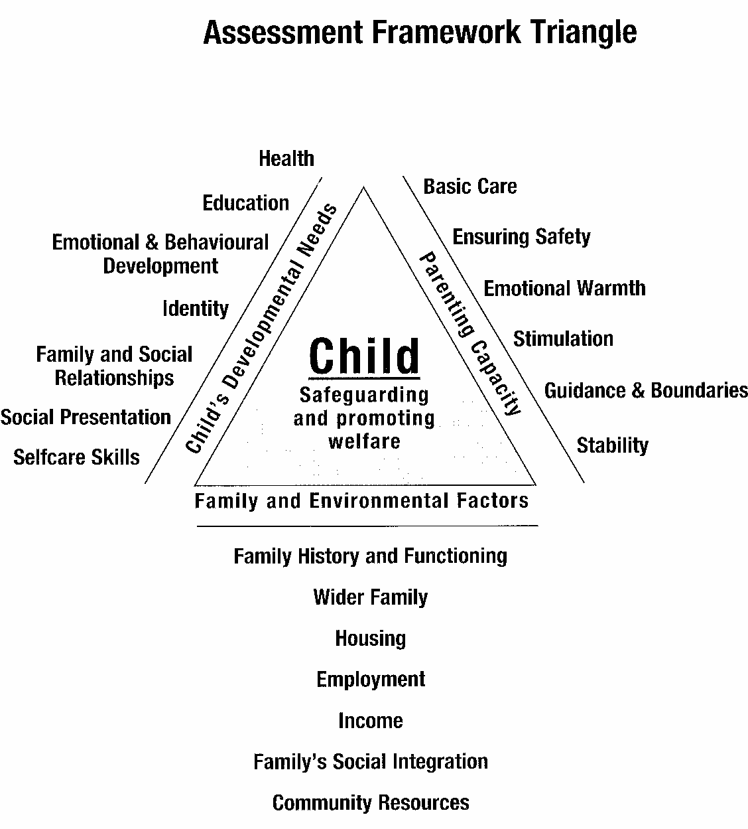

22. Roles and responsibilities of single point of contact

PREVENTING VIOLENT EXTREMISM -
ROLES AND RESPONSIBILITIES OF THE SINGLE POINT OF CONTACT (SPOC)

The SPOC for Woodfall Primary and Nursery School is Helen Hough, who is responsible for:

- Ensuring that staff of the school are aware that you are the SPOC in relation to protecting students/pupils from radicalisation and involvement in terrorism;
- Maintaining and applying a good understanding of the relevant guidance in relation to preventing students/pupils from becoming involved in terrorism, and protecting them from radicalisation by those who support terrorism or forms of extremism which lead to terrorism;
- Raising awareness about the role and responsibilities of (School / Service) in relation to protecting students/pupils from radicalisation and involvement in terrorism;
- Monitoring the effect in practice of the school’s RE curriculum and assembly policy to ensure that they are used to promote community cohesion and tolerance of different faiths and beliefs;
- Raising awareness within the school about the safeguarding processes relating to protecting students/pupils from radicalisation and involvement in terrorism;
- Acting as the first point of contact within the school for case discussions relating to students / pupils who may be at risk of radicalisation or involved in terrorism;
- Collating relevant information from in relation to referrals of vulnerable students / pupils into the Channel* process;
- attending Channel* meetings as necessary and carrying out any actions as agreed;
- Reporting progress on actions to the Channel* Co-ordinator; and
- Sharing any relevant additional information in a timely manner.

* Channel is a multi-agency approach to provide support to individuals who are at risk of being drawn into terrorist related activity. It is led by Cheshire West and Chester Local Authority and the Cheshire Police Counter-Terrorism Unit, and it aims to:
- Establish an effective multi-agency referral and intervention process to identify vulnerable individuals;
- Safeguard individuals who might be vulnerable to being radicalised, so that they are not at risk of being drawn into terrorist-related activity; and
- Provide early intervention to protect and divert people away from the risks they face and reduce vulnerability.

Wherever the word “staff” is used, it covers ALL staff on site, including ancillary supply and self-employed staff, contractors, volunteers working with children etc. and governors.
Guidance regarding DBS checks recently updated by the Protection of Freedoms Act 2012
The UK Data Protection Act 2018 (DPA 2018) is supplementary to the General Data Protection Regulation 2016 (the GDPR) and replaces DPA 1998.
Refer to “Guidance for Safe Working Practice”
The UK Data Protection Act 2018 (DPA 2018) is supplementary to the General Data Protection Regulation 2016 (the GDPR) and replaces DPA 1998.
The Prevent duty
Promoting Fundamental British Values
FGM procedural information
Mental health and behaviour in schools: guidance
CME Statutory Guidance for Local Authorities
Preventing youth violence and gang involvement
Sexting in schools and colleges
Sharing nudes and semi-nudes: how to respond to an incident (UCKIS)

